# Exploring prompt engineering

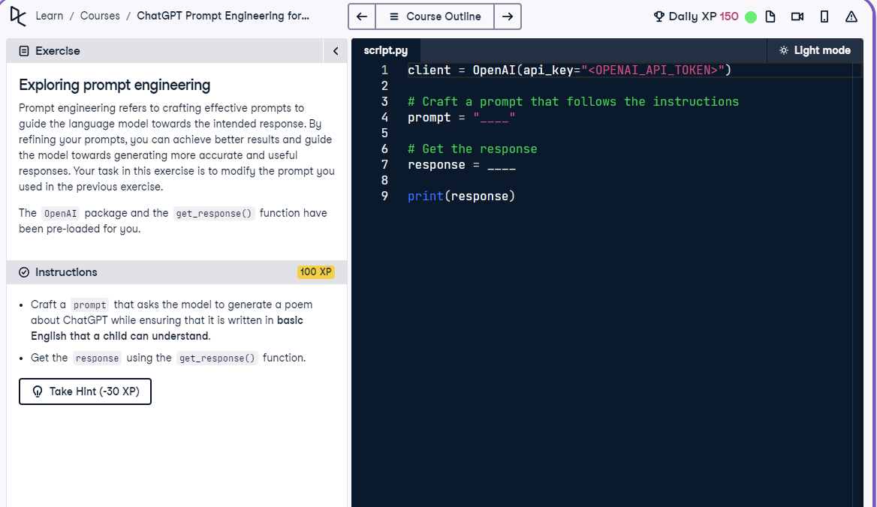

## Question

Craft a prompt that asks the model to generate a poem about ChatGPT using basic English that a child can understand.

## Question Explanation

In this task, the goal is to refine a prompt so that the language model returns a simple, easy-to-understand poem about ChatGPT. The instructions specifically require using basic English that would be clear to a child. The get_response() function is used to retrieve the output.

## Answer

client = OpenAI(api_key="<OPENAI_API_TOKEN>")  
  
# Craft a prompt that follows the instructions  
prompt = "Write a poem about ChatGPT using basic English that a child can understand."  
  
# Get the response  
response = get_response(prompt)  
  
print(response)

## Answer Explanation

This updated prompt directly asks the model to create a poem about ChatGPT in basic English that a child can understand. It uses precise and simple wording to match the instructional requirement. The prompt is passed to get_response() to generate and display the output.